**CLOUD COMPUTING DAY-3 QUESTIONS**

**USING AZURE**

**15. Demonstrate Platform as a Service (PaaS) create and configure a new VM Image in any Public Cloud Service Provider Procedure:**

1.After creating the one virtual machines.

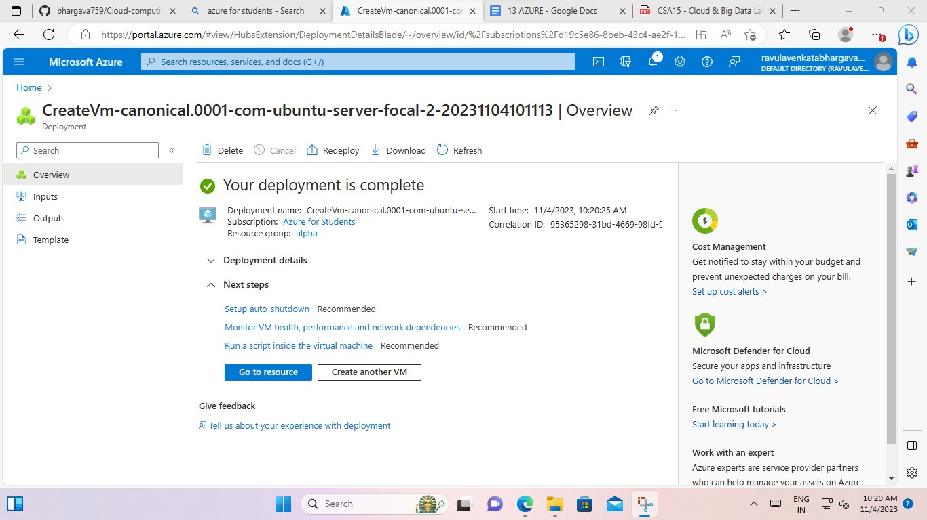

2.to show the virtual machines and select the one virtual machine.

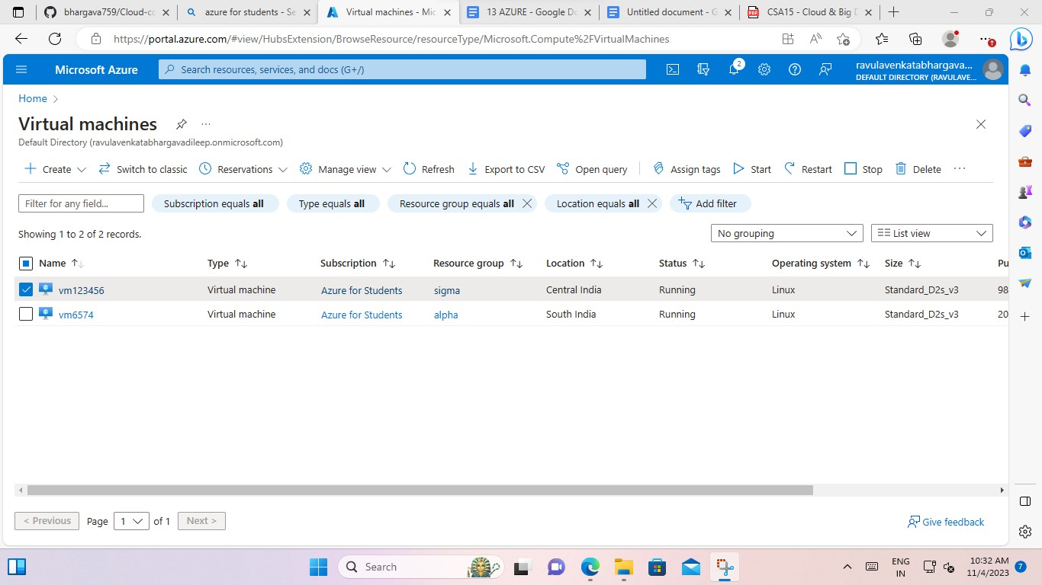

1. And give the connection and select the (ssh using azure cli).

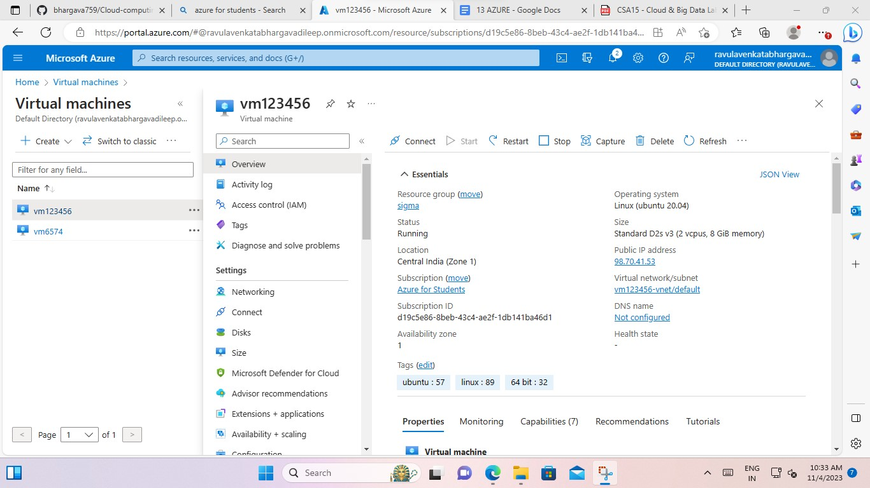

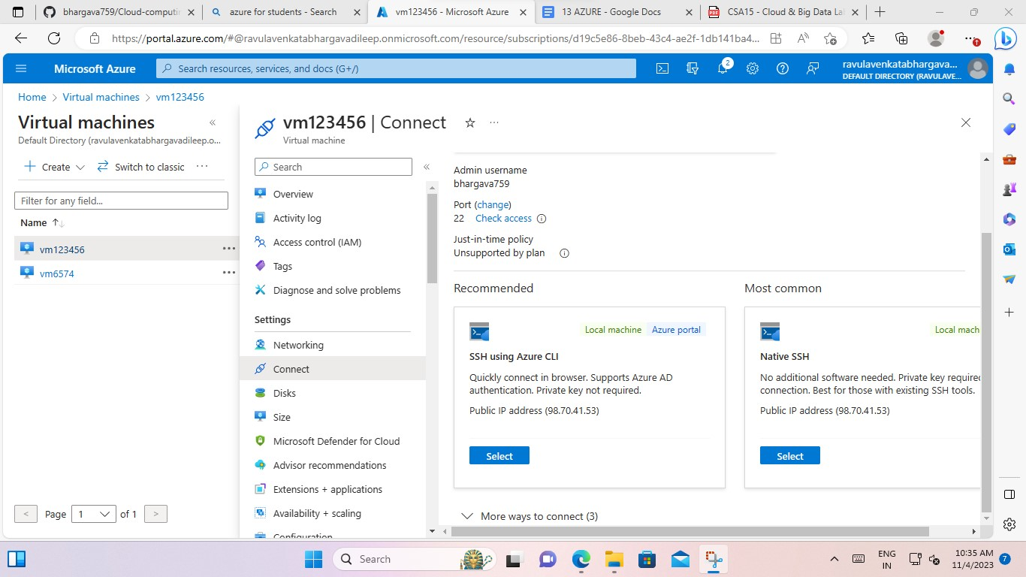

1. And select the (ssh using azure cli). Give the tick mark for understand process.to make sure to configure and connect is option is to tap.

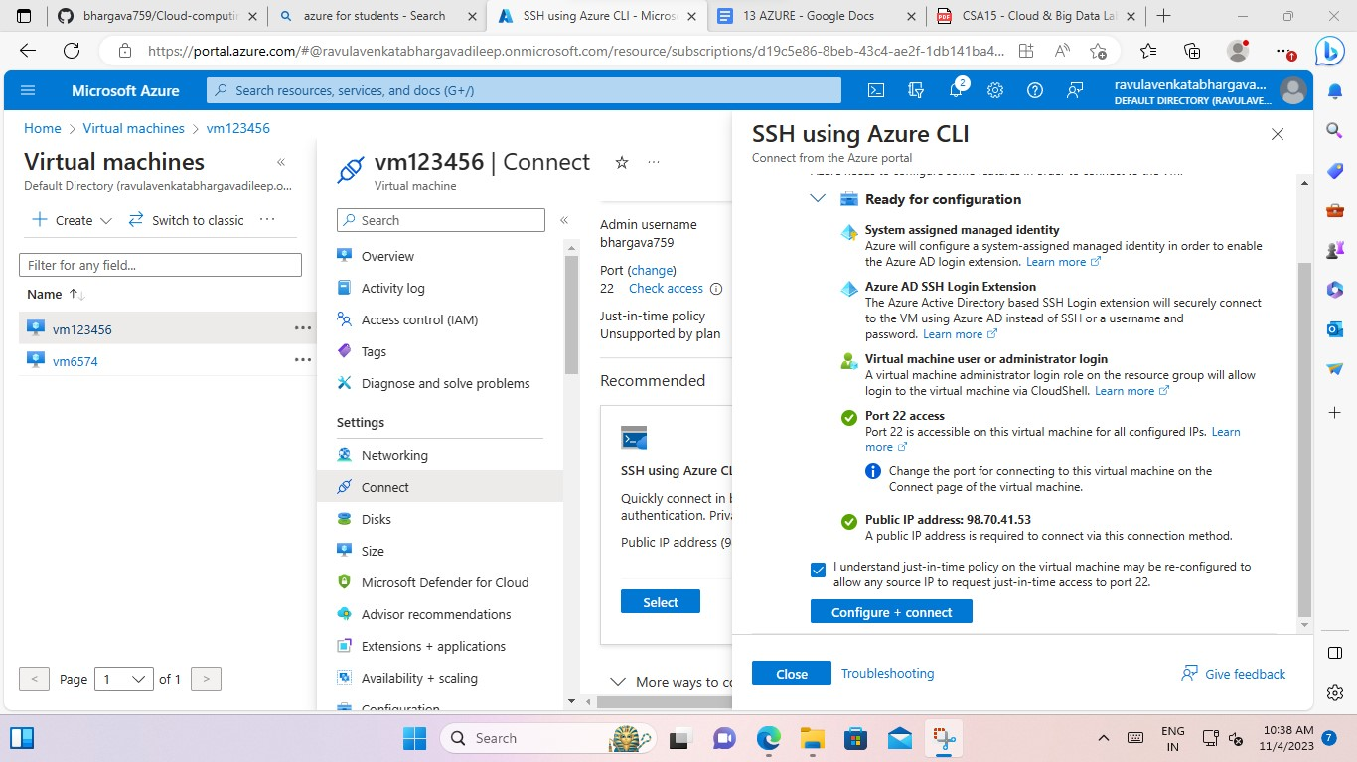

5.And after one bash command prompt is open and to create the storage of that virtual machine.

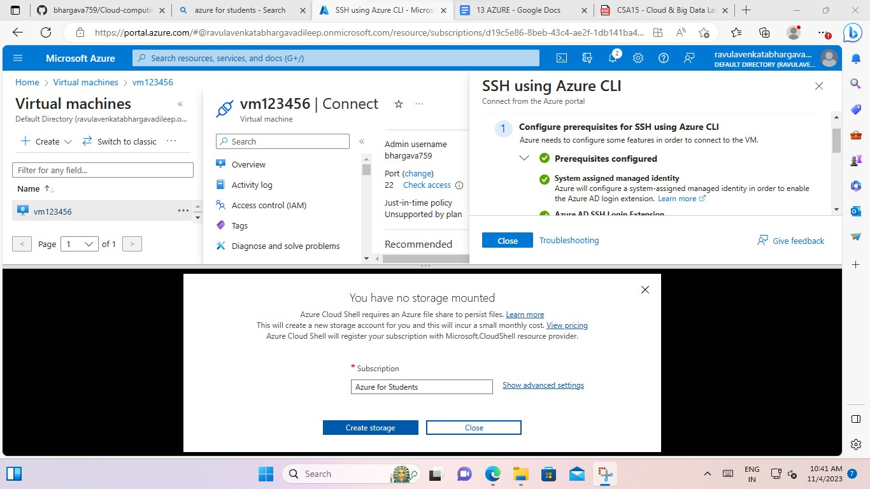

6. And its shows successful message.

